Sonata in E-flat Major, Hob. XVI/52 J. Haydn (1732-1809)
I. Allegro
II. Adagio
III. Finale: Presto
Jack Stabile

Intermezzo, Op. 117, No. 2 J. Brahms (1833-1897)
Intermezzo, Op. 118, No. 2.

Allan Wang

La plus que lente C. Debussy (1862-1918)

Mark Ross

Intermission

Guitar, Op.32…………………….. C. Chaminade (1857-1944)

Stuart Rosenthal

The Maiden and the Nightingale Enrique Granados (1867-1916)
from Goyescas

Danzas Argentinas, Op. 2.………………………………...A. Ginastera
(1916-1983)
- Dance of the Old Herdsman
- Dance of the Beautiful Maiden
- Dance of the Clever Cowboy

Simon Finlow

Cuban Overture (piano duet) G. Gershwin (1898-1937)

Louis Reichwein and Kuo-Wei Wang

AMSF
The Adult Music Student Forum (AMSF) promotes the educational and performance interests of adult amateur musicians. All non-professional, non- collegiate instrumental and vocal musicians are welcome to join.
AMSF members include musicians at every level: beginners, those returning to music after many years, and relatively advanced players. AMSF offers many opportunities to perform, share enthusiasm, learn new ideas, and continue to grow both in skill and in appreciation of the musical experience. For more information, see www.amsfperform.org.

AMSF Recitals
AMSF affords many performance opportunities for its members. Most recitals are held in member homes. See the website for a description of the various recital series and schedules. www.amsfperform.org
Encore recitals are held several times a year in various Washington-area churches and recital halls. Attendance is free and open to the public. Performer participation is primarily for members of intermediate to advanced levels of skill and experience.

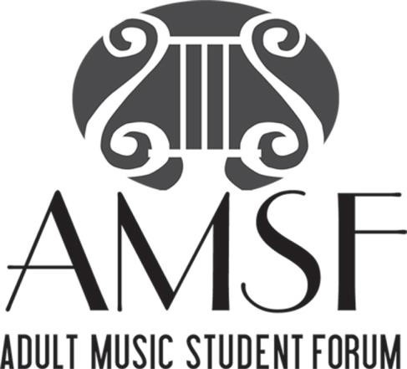

presents

ENCORE RECITAL

AMSF President: Michelle Powell
AMSF Encore Recital Coordinator: Stuart Rosenthal
2:00 p.m.
Sunday, June 29, 2025

Ingleside at Rock Creek

Washington, DC

